Chip Whiteside

Final Project Report

12/3/2019

Functionality/Requirements:

* User can start game, go to settings or exit game from main menu.
* When playing, user can move and shoot simultaneously.
* The goal of finding the key to unlock the floor boss should be clear and should be possible.
* All three “special” rooms (boss room, chest/key room, and upgrade room) should be accessible from the start room.
* The game shouldn’t crash on startup or during gameplay
* Player health should work, and the game should end when the user’s health is depleted
* The player should be able to continue playing until they run out of health by going down further after each boss fight.

Design Documents:

(Initial drawing of the prototype for the game’s UI)

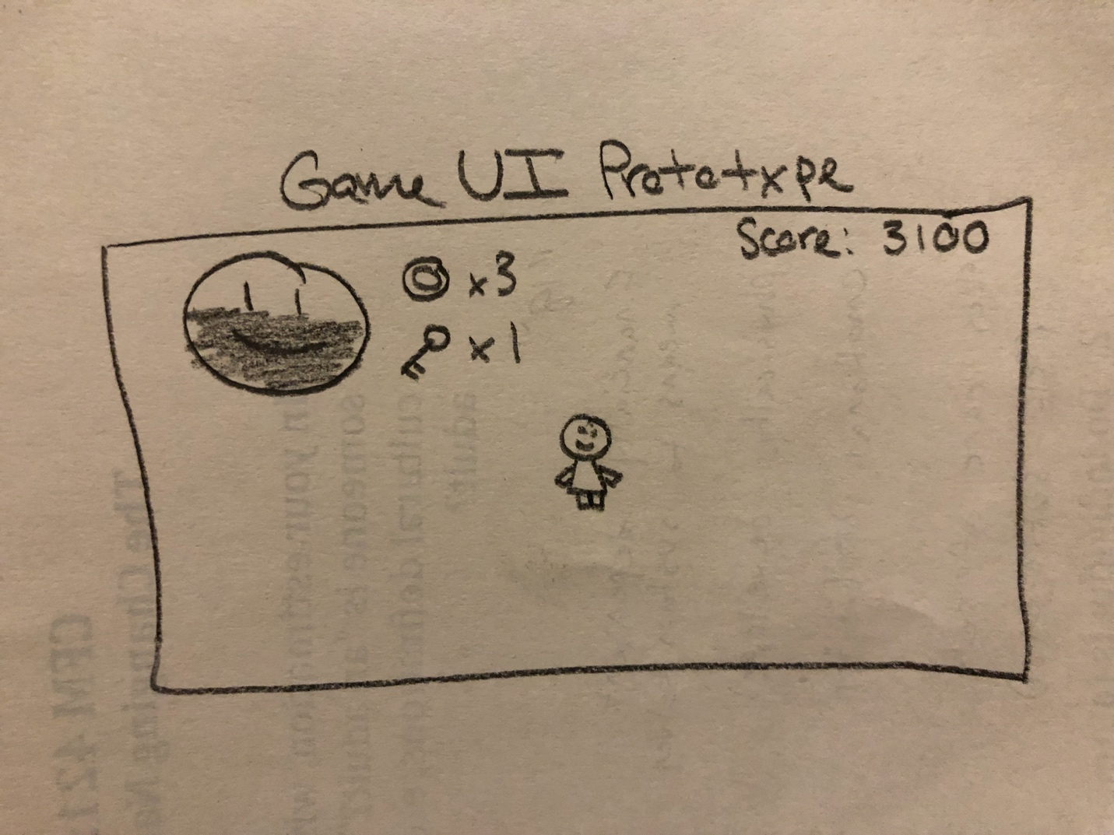

(Initial drawing of the prototype for the game’s start menu, which is over-layed on the actual game so the transition between menu and playing is seamless)

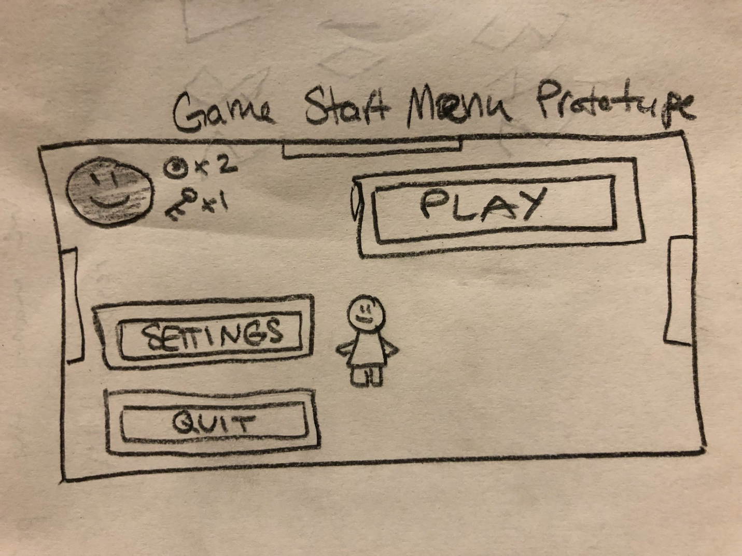

Tools:

The tools I used were exclusively SpriteKit tools, such as the SKPhysics system and the SpriteKit inheritance model.

User guidelines:

Screenshots:

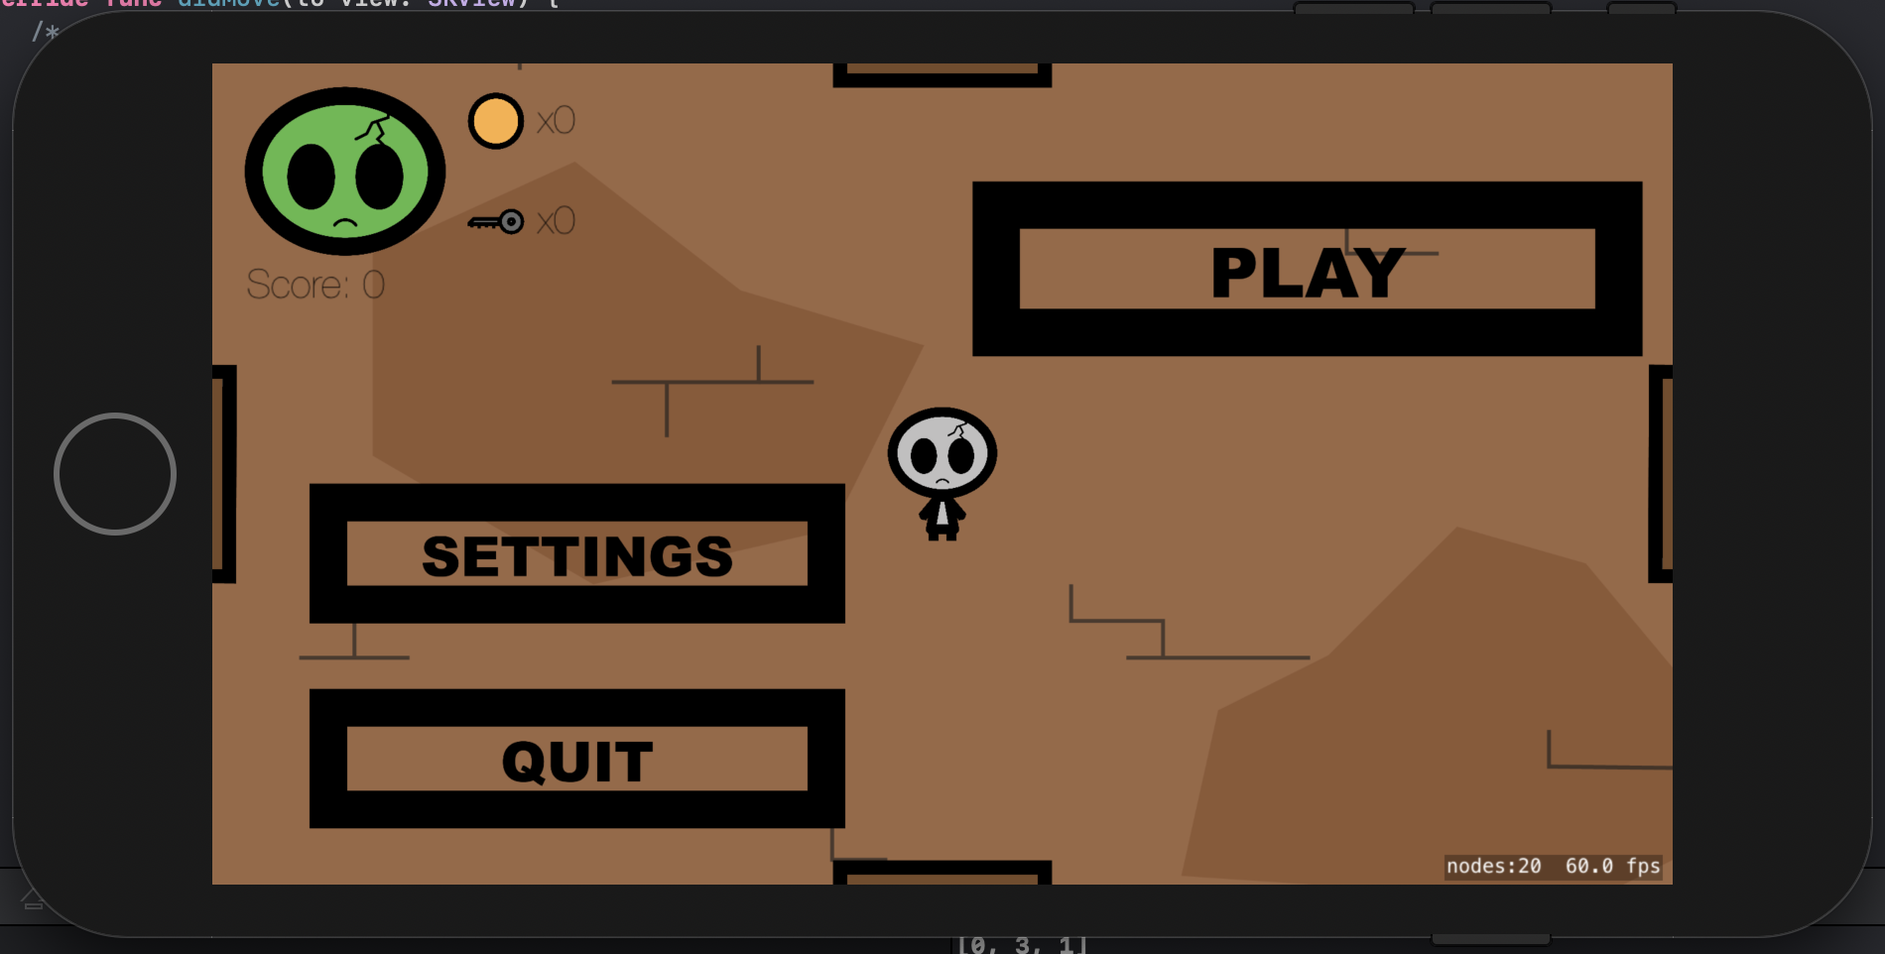

(Main menu)

(Playing view)

(Moving down)

(Shooting right)

(Enemy encounter & loosing health)

(Closed chest)

(Open chest and key item)

(Shot upgrade item)

(Shot upgrade firing)

(Boss fight)

(Ladder to descend to next level)

User Manual:

Objective:

Get the highest score you can before dying. Killing an enemy (regular or boss) will award you with points based on what level you are and what type of enemy is killed. In each level are five types of rooms, the spawn room, which is where the player starts when they get to the level, the enemy encounter, which has a number of enemies spawn with the intention of killing the player, the upgrade room which spawns an upgrade to the user’s weapon, the chest room which contains a chest containing a key that unlocks the boss room, and finally the boss room which spawns the floor boss. Once the floor boss is killed the stairs down to the next level will spawn allowing the player to continue.

Controls:

The user can move the player character by touching the left side of the screen, which creates a virtual joystick, and moving your finger above where you initially touched will move the player up, similar actions will move the player in the direction you move your finger while you hold down on the screen. Shooting is done in a identical way except on the right side of the screen.

Items:

* Keys are collected from the floor chest and used to unlock the boss room
* Coins have a chance to drop when killing an enemy and are used to purchase life, keys or upgrades from the shop (not implemented yet)
* Hearts have a chance to drop from a dead enemy similar to coins and when picked up refill apportion of the players health.